9-3: Set Operators

Vocabulary

operator that returns all rows from both tables and eliminates duplicates UNION

columns that were made up to match queries in another table that are not in both tables TO_CHAR(NULL)

operator that returns all rows from both tables, including duplicates UNION ALL

used to combine results into one single result from multiple statements SELECT

operator that returns rows that are unique to each table MINUS

operator that returns rows common to both tables INTERSECT

Try It / Solve It

1. Name the different Set operators?

**UNION**

**UNION ALL**

**MINUS**

**INTERSECT**

1. Write one query to return the employee_id, job_id, hire_date, and department_id of all employees and a second query listing employee_id, job_id, start_date, and department_id from the job_history table and combine the results as one single output. Make sure you suppress duplicates in the output.

1. Amend the previous statement to not suppress duplicates and examine the output. How many extra rows did you get returned and which were they? Sort the output by employee_id to make it easier to spot.

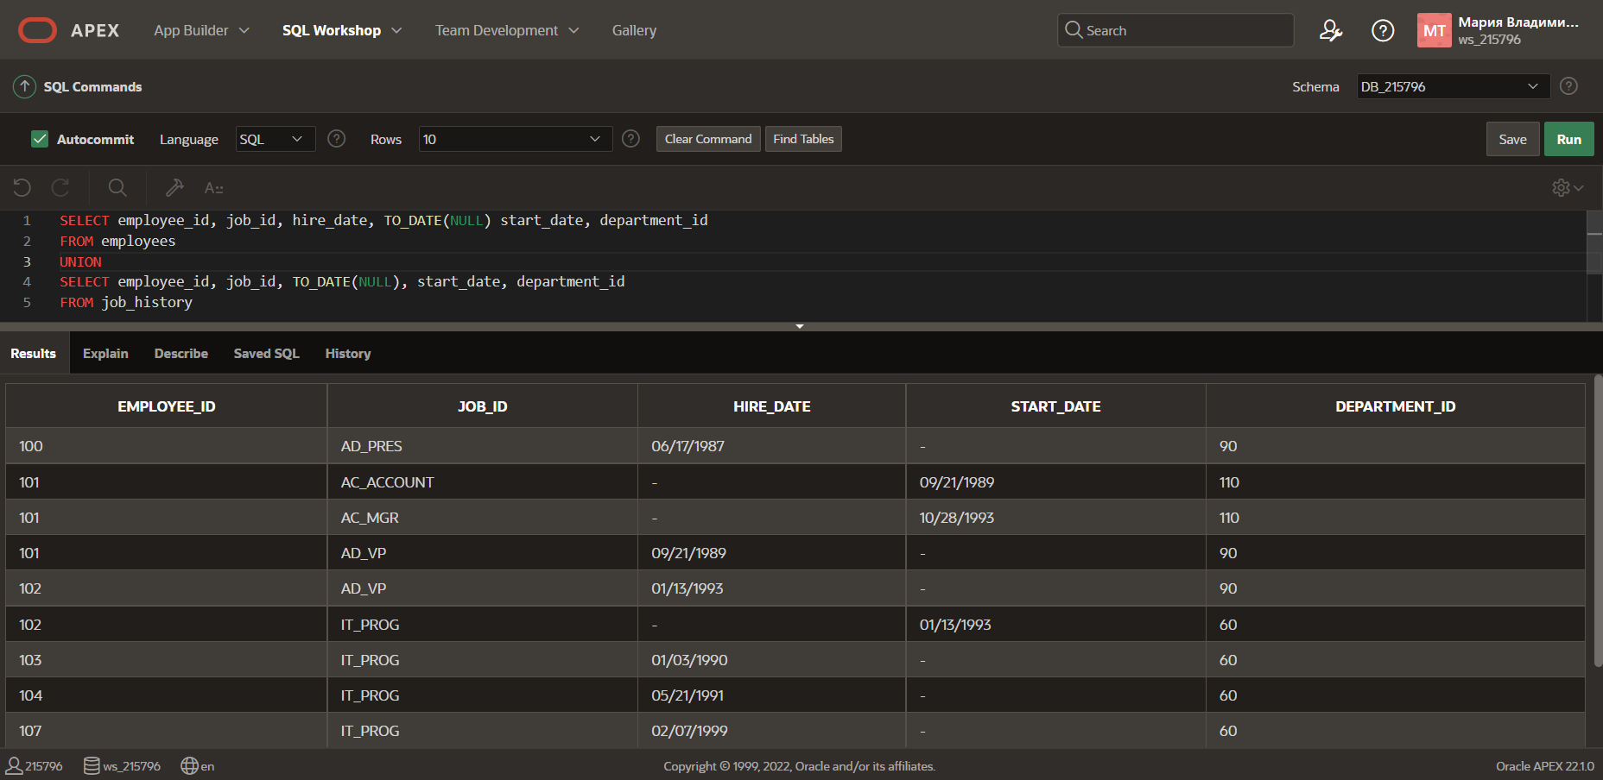

1. List all employees who have not changed jobs even once. (Such employees are not found in the job_history table)

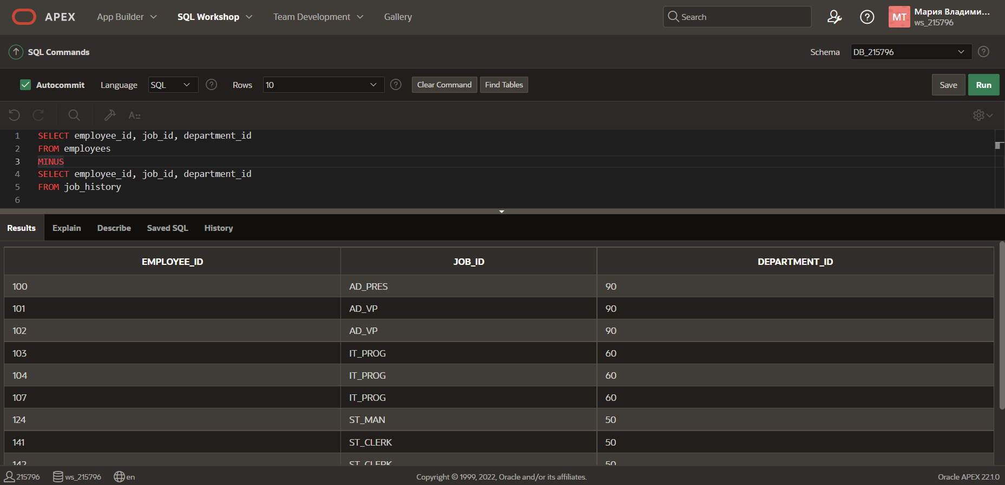

1. List the employees that HAVE changed their jobs at least once.

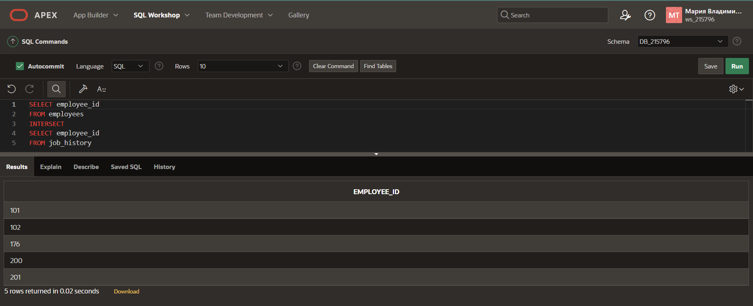

1. Using the UNION operator, write a query that displays the employee_id, job_id, and salary of ALL present and past employees. If a salary is not found, then just display a 0 (zero) in its place.

